Lab # Customizations

Hands-on lab Step-by-Step

September 2021

# Lab Overview and Pre-requisites

This beginner-level lab gives you hands-on experience designing and developing a virtual agent, customer voice and adding images to sub grid in Model Driven Apps.

Here’s what you’ll learn:

* **Power Virtual Agent:** Create a Virtual Agent to answer top topics to offboard agent workload.

# Exercise 1: Automate topics for a Power Virtual Agents bot

You must have the following to automate a topic from Customer Service Insights to Power Virtual Agents:

* A valid license to access Power Virtual Agents. Go to <https://aka.ms/TryPVA> for more information and to sign up for a trial.
* A bot created in Power Virtual Agents.

## Task 1: Enabling Bot Automation from Customer Analytics

1. Navigate to Service Management area

1. Select **Settings** in **Insights** group.

1. Select **Manage on topic clustering for case** then go to the bottom area of the page.

1. Enable Power Virtual Agents.

You can see Analytics reports by navigating to the Service > Analytics and Insights > Customer Service historical analytics page. By default, the Summary page is displayed.

After reviewing topic details and identifying a candidate for automation, you can automate the topic from the topic details page:

1. In the topic details page, select **Automate to bot** at the top.

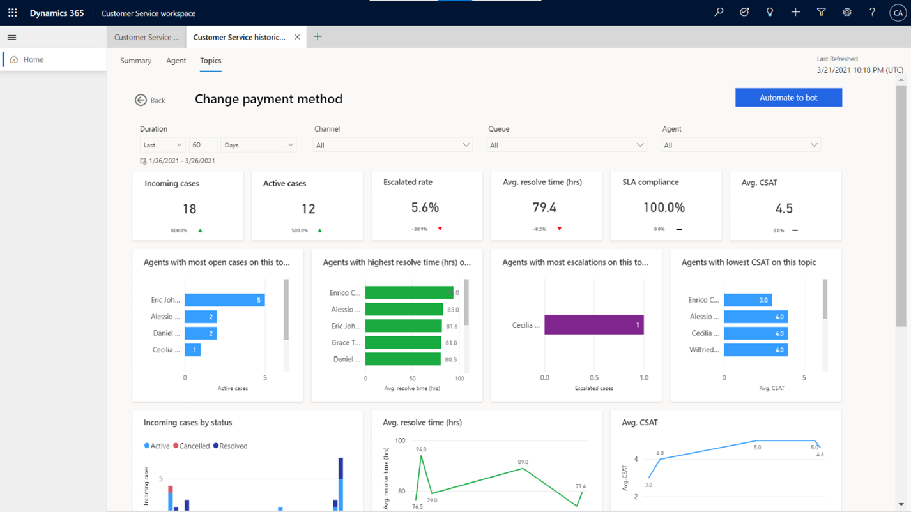

1. Customer Service Insights creates a new topic in Power Virtual Agents in a new browser tab.

The Name and Trigger phrases are prefilled from the topic you selected for automation.

Customer Service Insights prefills Trigger phrases with non-duplicated case titles from the most relevant cases (up to three cases).

[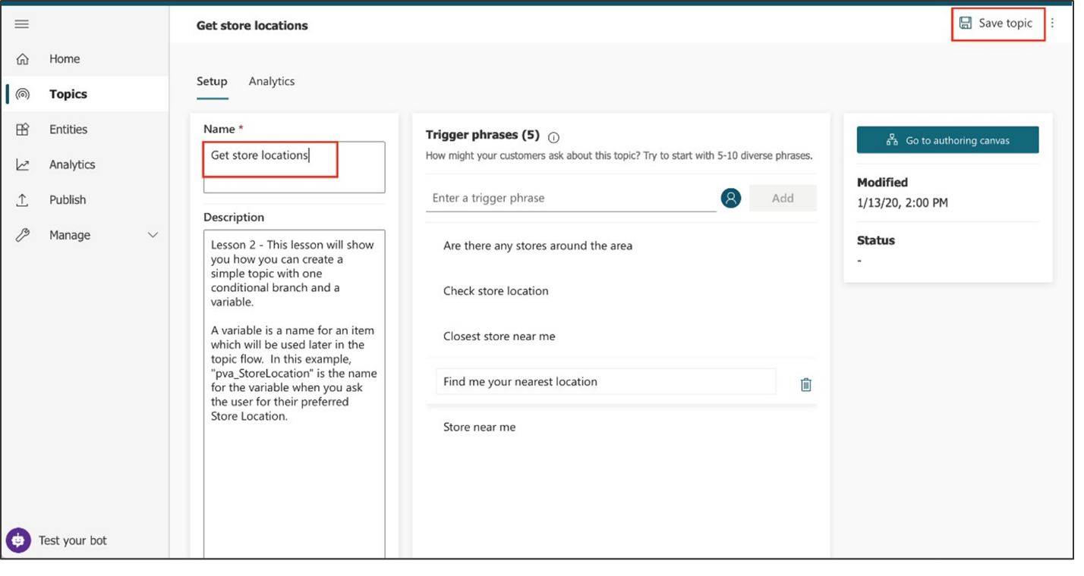](https://docs.microsoft.com/en-us/learn/modules/power-virtual-agents-bots/media/lab-11.png#lightbox)

1. Review the topic name and trigger phrases and click **Save topic** and follow the other steps in the Create custom topics for your bot article to complete the creation of your bot topic.

## Task 2: Create/Edit the topic

1. Select the name of the topic to open the topic or click **Go to authoring canvas** if you are already inside the topic.
2. Select the current text in the **Name** field, delete it, and type to rename the topic to **Get store locations**.
3. Select **Save topic** in the upper right corner of the page.

[](https://docs.microsoft.com/en-us/learn/modules/power-virtual-agents-bots/media/lab-11.png#lightbox)

1. Let's imagine you opened a new store in Bellevue. To add the store info to your bot, you need to edit the topic design in the authoring canvas. Select **Go to authoring canvas**.

The authoring canvas contains all the text and logic for the conversation about store locations. At the top, you'll see a reminder of the trigger phrases, which are added and edited on the **Setup** page.

[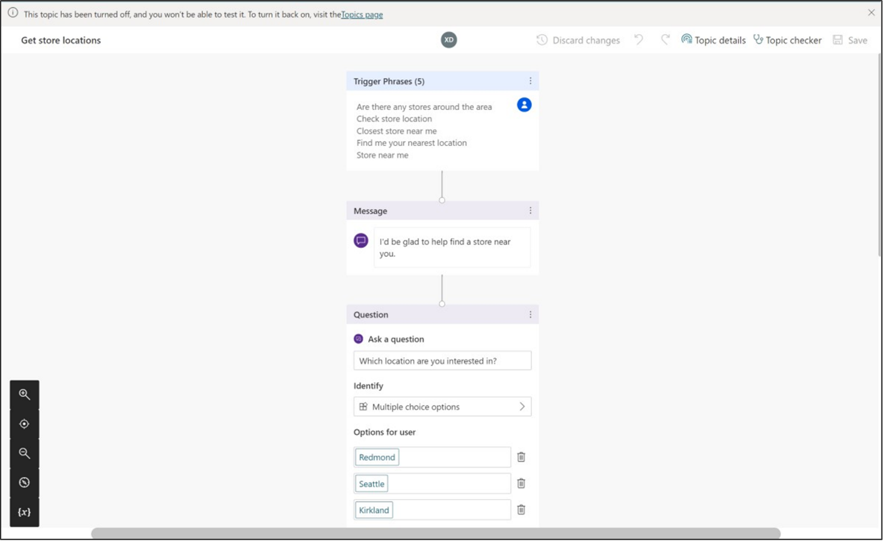](https://docs.microsoft.com/en-us/learn/modules/power-virtual-agents-bots/media/lab-12.png#lightbox)

1. Scroll down the page to see the conversation design.

Each of the connected boxes you see is called a "node." You can see that the bot displays a message in a **Message** node that it's happy to help find a store location and then asks in a **Question** node which location the user is interested in. (You can reopen the test bot to see that this is the same as the conversation you had in Exercise 2. Then close the test bot again.)

1. Scroll to the Question node that asks "Which location are you interested in?". We're going to add another option here.
2. Under "Redmond" "Seattle" "Kirkland," select **+ New option**.

[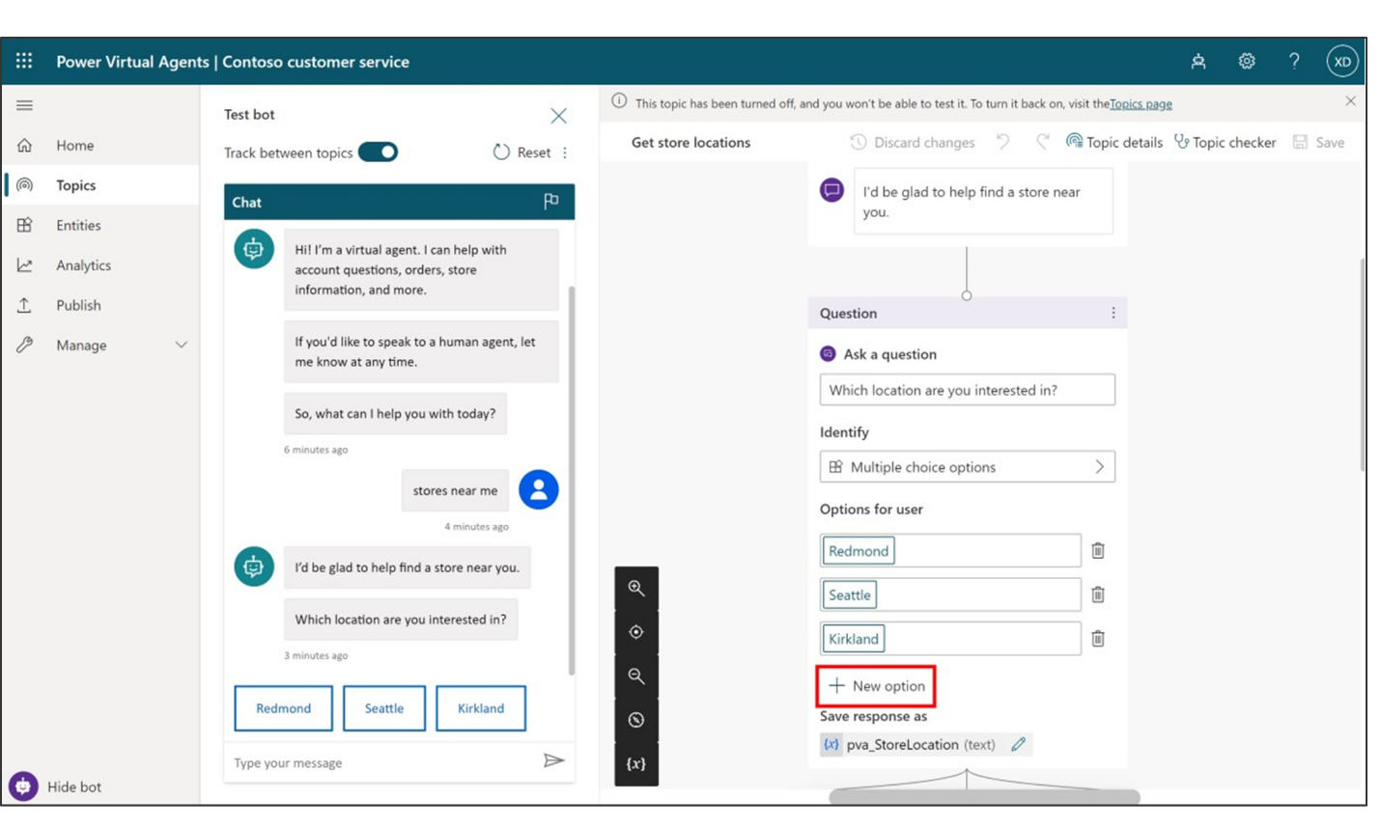](https://docs.microsoft.com/en-us/learn/modules/power-virtual-agents-bots/media/lab-13.png#lightbox)

A new **Condition** node is added under the Question node.

[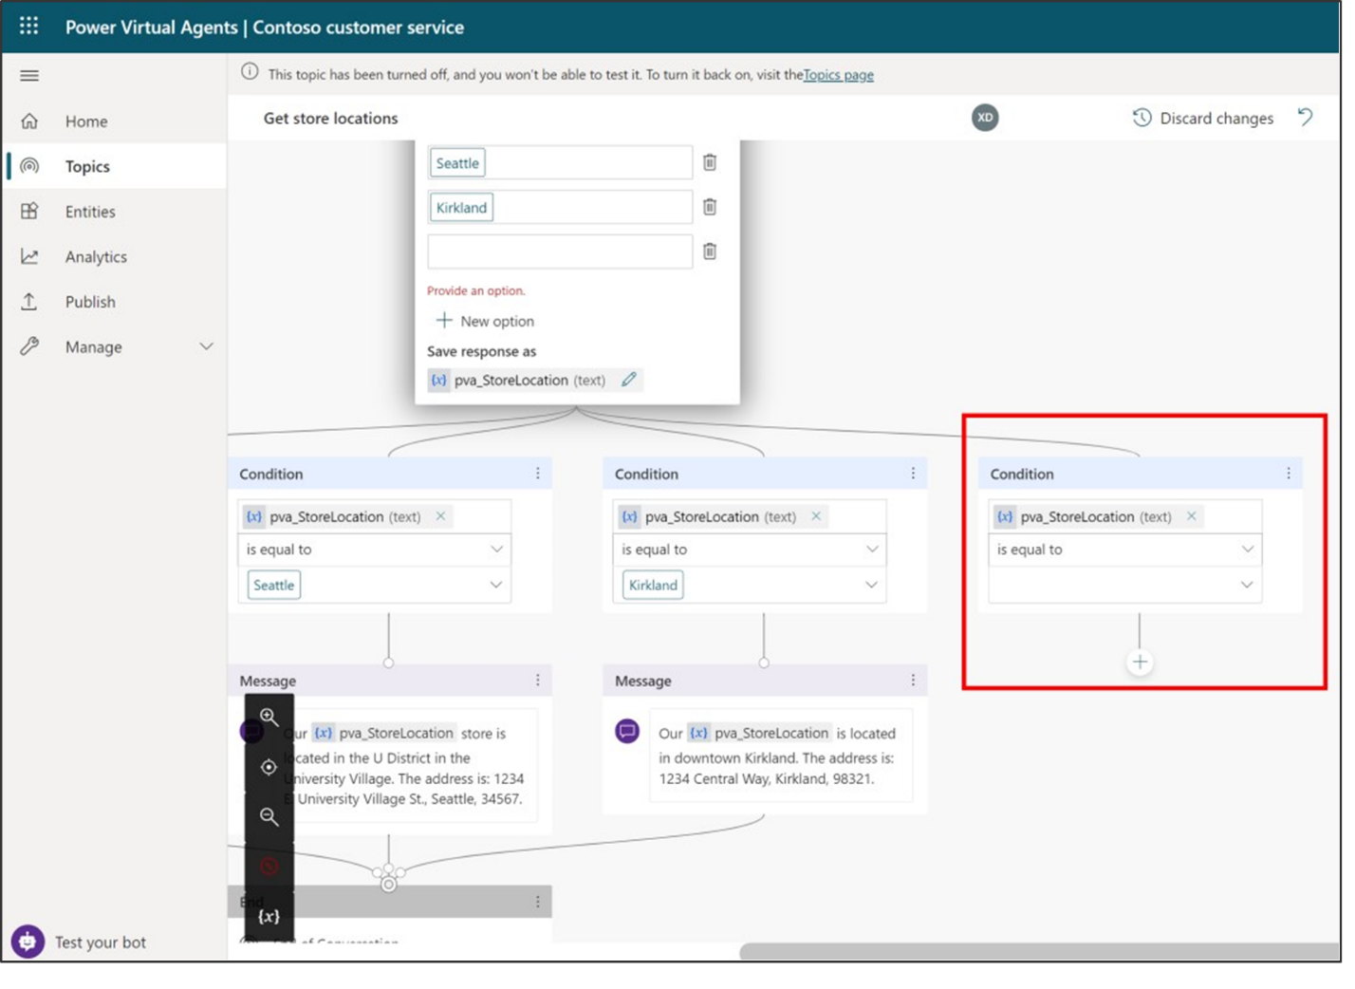](https://docs.microsoft.com/en-us/learn/modules/power-virtual-agents-bots/media/lab-14.png#lightbox)

1. In the Question node (**NOT** in the Condition node), type **Bellevue** in the newly added empty box under **Options for user**.

**Bellevue** is automatically added for you in the Condition node too.

[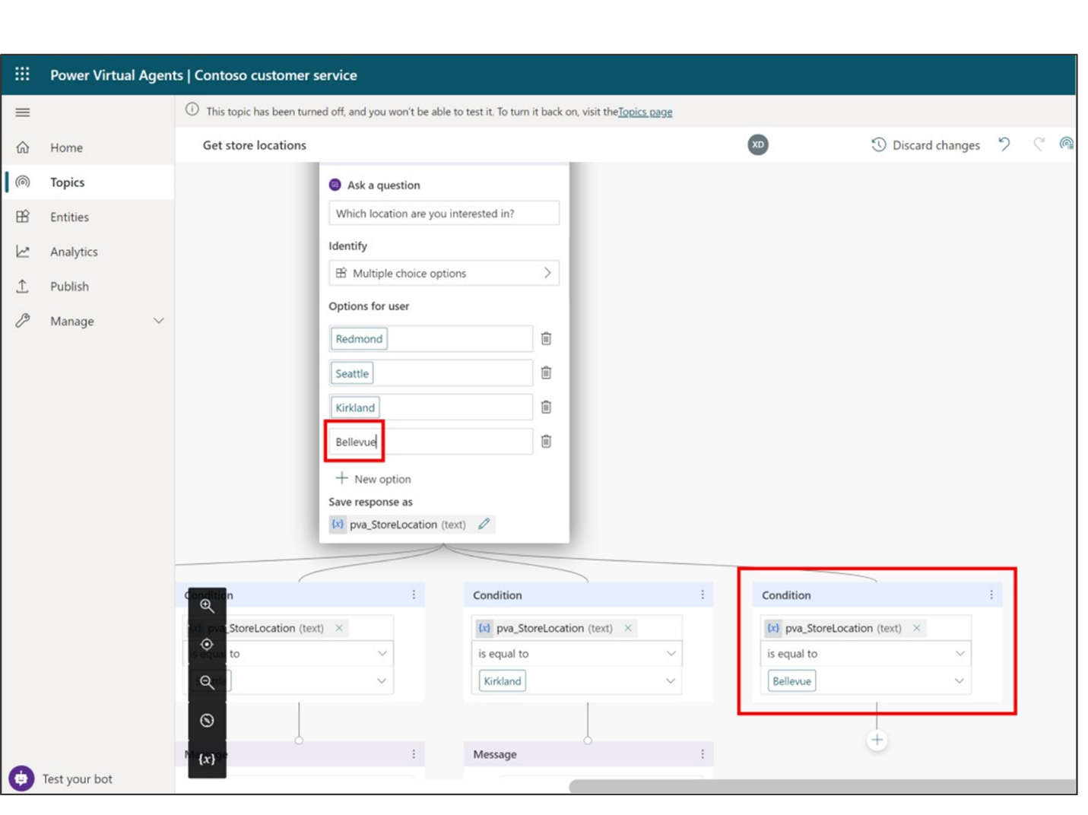](https://docs.microsoft.com/en-us/learn/modules/power-virtual-agents-bots/media/lab-15.png#lightbox)

**Note**

The **Options for user** section controls what buttons are visible to users in the chat window, and always need to be matched with a condition, or the button won't work. The Conditions, however, can handle the user typing something that is not shown in a button. So for instance if you were to delete the Bellevue **Options for user** button, it would not delete the Bellevue Condition node, which would be used if the user types "Bellevue" when asked for a location.

Now, you'll tell the bot what message to display if the user selects **Bellevue**. The new condition node looks like this:

[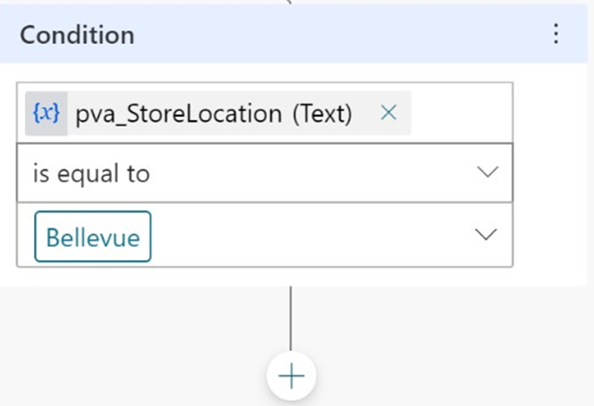](https://docs.microsoft.com/en-us/learn/modules/power-virtual-agents-bots/media/lab-16.png#lightbox)

1. From the options that appear, select **Show a message**.

[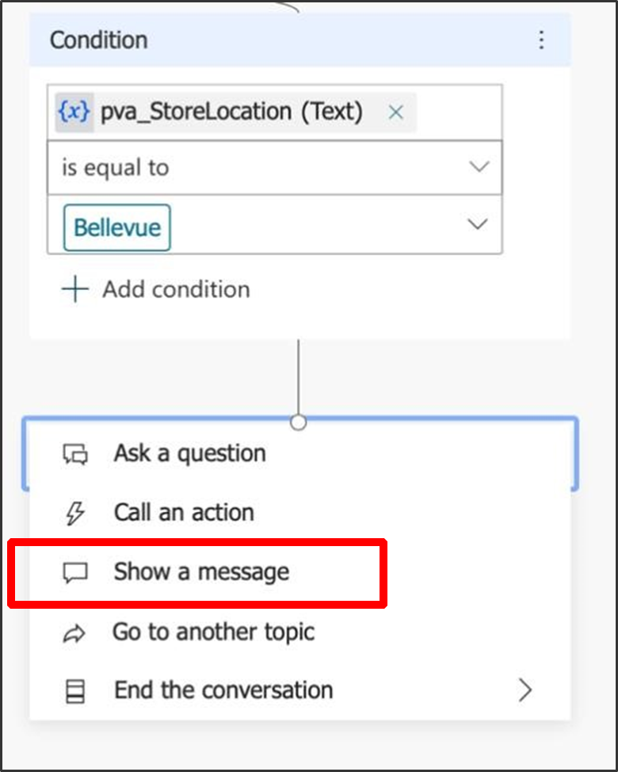](https://docs.microsoft.com/en-us/learn/modules/power-virtual-agents-bots/media/lab-17.png#lightbox)

This adds a new Message node connected to the Bellevue condition.

1. In the Message node, enter the store location info: **Our Bellevue store is in 1234 Bellevue Way, Bellevue, WA 98123.**

[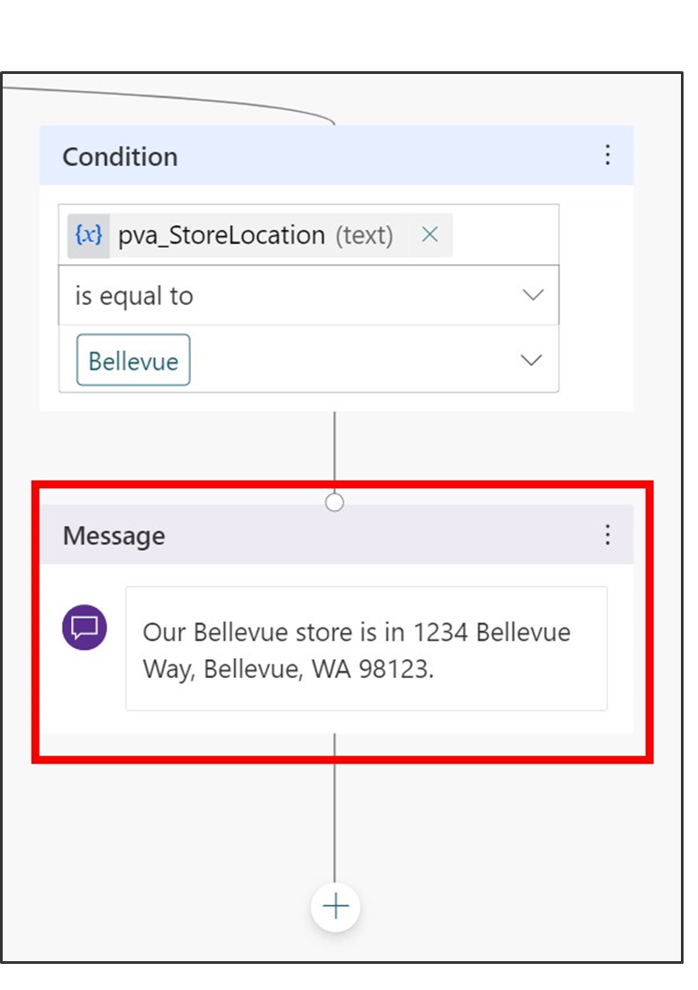](https://docs.microsoft.com/en-us/learn/modules/power-virtual-agents-bots/media/lab-18.png#lightbox)

**Note**

You can format the message text using the formatting buttons that appear while you're typing. You can even replace the name of the location with the value of the pva_StoreLocation variable by using the {x} control.

You are now going to end the conversation. Since the conversation ends the same way no matter which location the user chose, we're going to link to a shared **End of conversation** node. This node starts the **End of conversation** system topic.

1. First, zoom out if necessary to see the **End of conversation** node on your screen. (**Zoom out** is in the utility bar on the left of the authoring canvas.)

[Screenshot of the utility bar features.](https://docs.microsoft.com/en-us/learn/modules/power-virtual-agents-bots/media/lab-19.png#lightbox)

1. Select the **Add node** button below the Bellevue location Message node.

[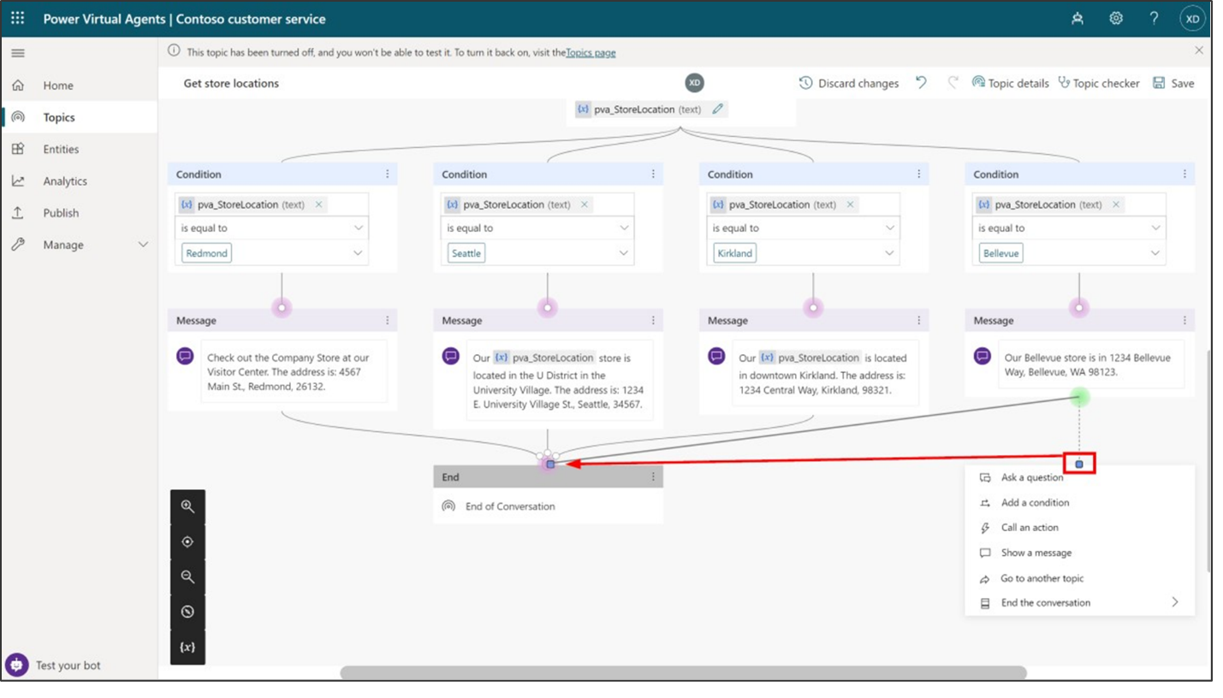](https://docs.microsoft.com/en-us/learn/modules/power-virtual-agents-bots/media/lab-20.png#lightbox)

1. When the list of options appears, instead of selecting an option, hover your mouse over the connector dot at the top, which will turn pink. Then select the dot and drag the connector to the left until you connect with the top of the **End of conversation** node (which is already connected to the other three location messages).

[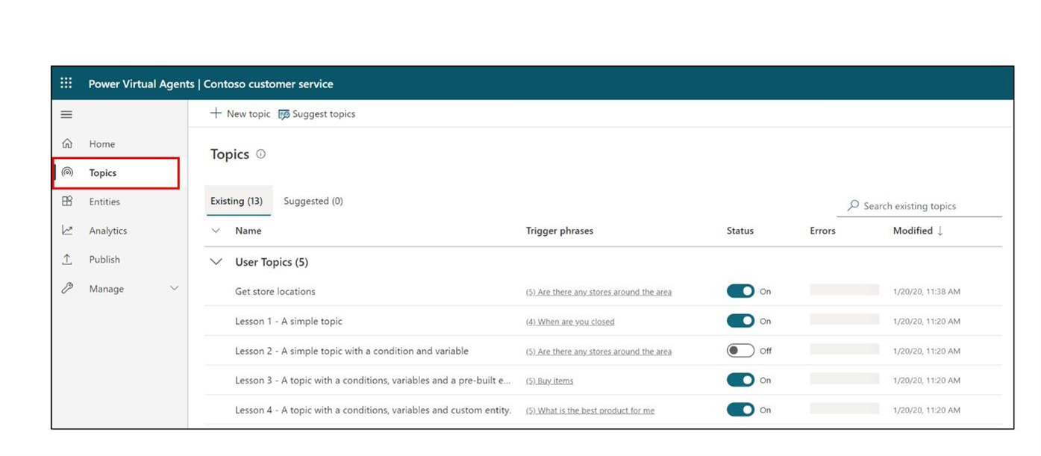](https://docs.microsoft.com/en-us/learn/modules/power-virtual-agents-bots/media/lab-21.png#lightbox)

1. At the top right of the page, select **Save** to save the changes you made.

## Task 3: Turn on your topic and test your changes

You may recall that when we made a copy of the Lesson 2 topic, the copy was created in an Off state. This means you can't trigger the topic in the test bot (and if you published your bot, your users couldn't trigger it either). We're ready to turn on the edited topic now.

1. Select the **Topics** tab in the left navigation to return to the Topics list.

[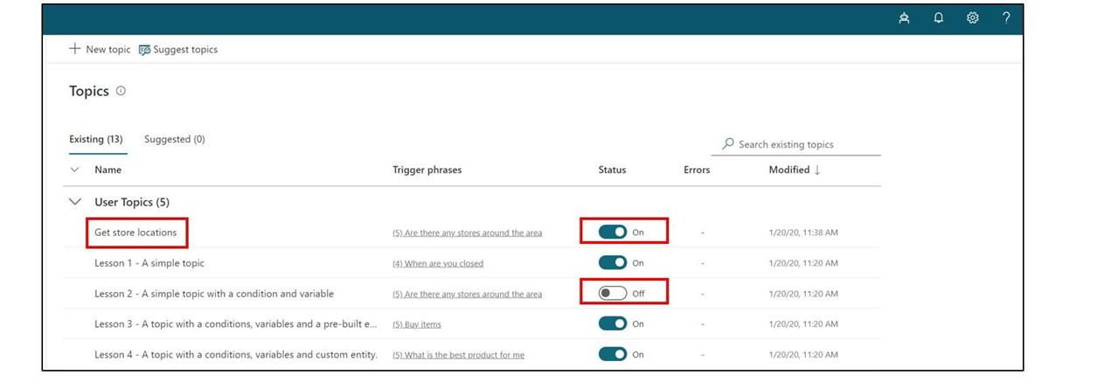](https://docs.microsoft.com/en-us/learn/modules/power-virtual-agents-bots/media/lab-22.png#lightbox)

1. Select the **Status** toggle from On to **Off** for **Lesson 2 - A simple topic with a condition and variable** and select the **Status** toggle from Off to **On** for **Get store locations.** Now, you can test the conversation you edited.

[](https://docs.microsoft.com/en-us/learn/modules/power-virtual-agents-bots/media/lab-23.png#lightbox)

1. In the bottom-left corner of the page, select **Test your bot**. Make sure the **Track between topics** toggle is set to the **On** position. In the test bot, enter **Is there a store near me?** and select the **Send** button.

[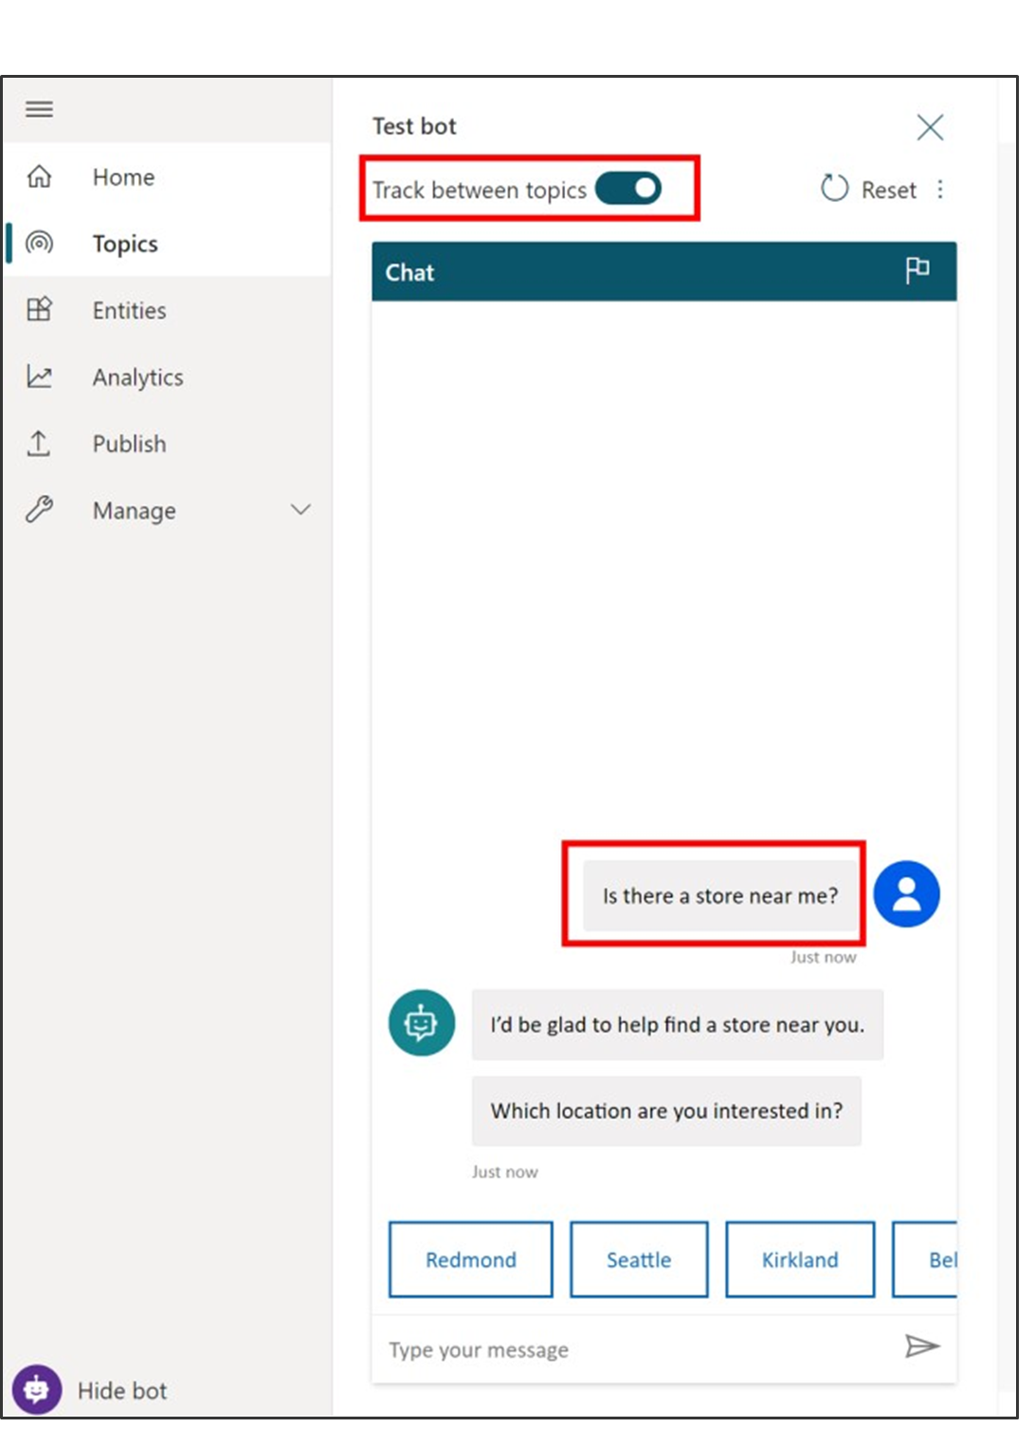](https://docs.microsoft.com/en-us/learn/modules/power-virtual-agents-bots/media/lab-24.png#lightbox)

Notice that even though it isn't exactly the same as the trigger phrases in the topic, "Is there a store near me?" works to trigger the topic because Power Virtual Agents understands that it means the same thing as the trigger phrases.

1. When asked to select a location, select the **Bellevue** location in the test chat. (You might need to use the onscreen right arrow to see the Bellevue option. If you don't see the option at all, make sure you did steps 1, 2, and 3 of this task.)

[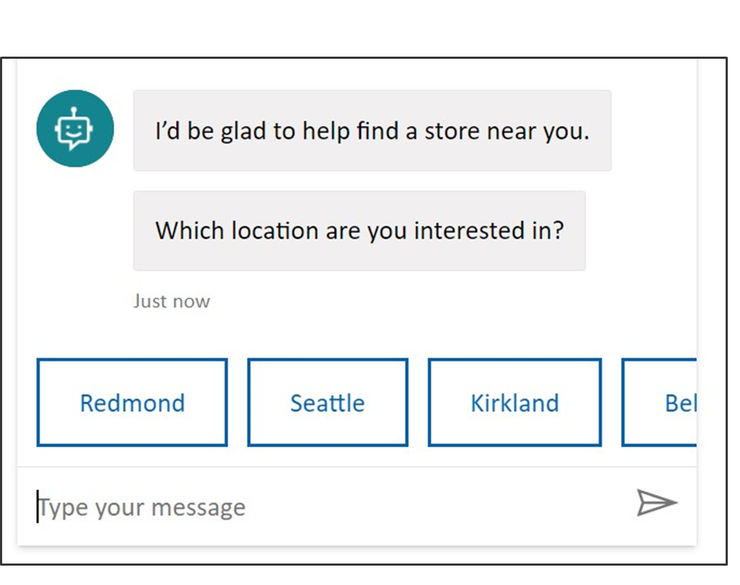](https://docs.microsoft.com/en-us/learn/modules/power-virtual-agents-bots/media/lab-25.png#lightbox)

[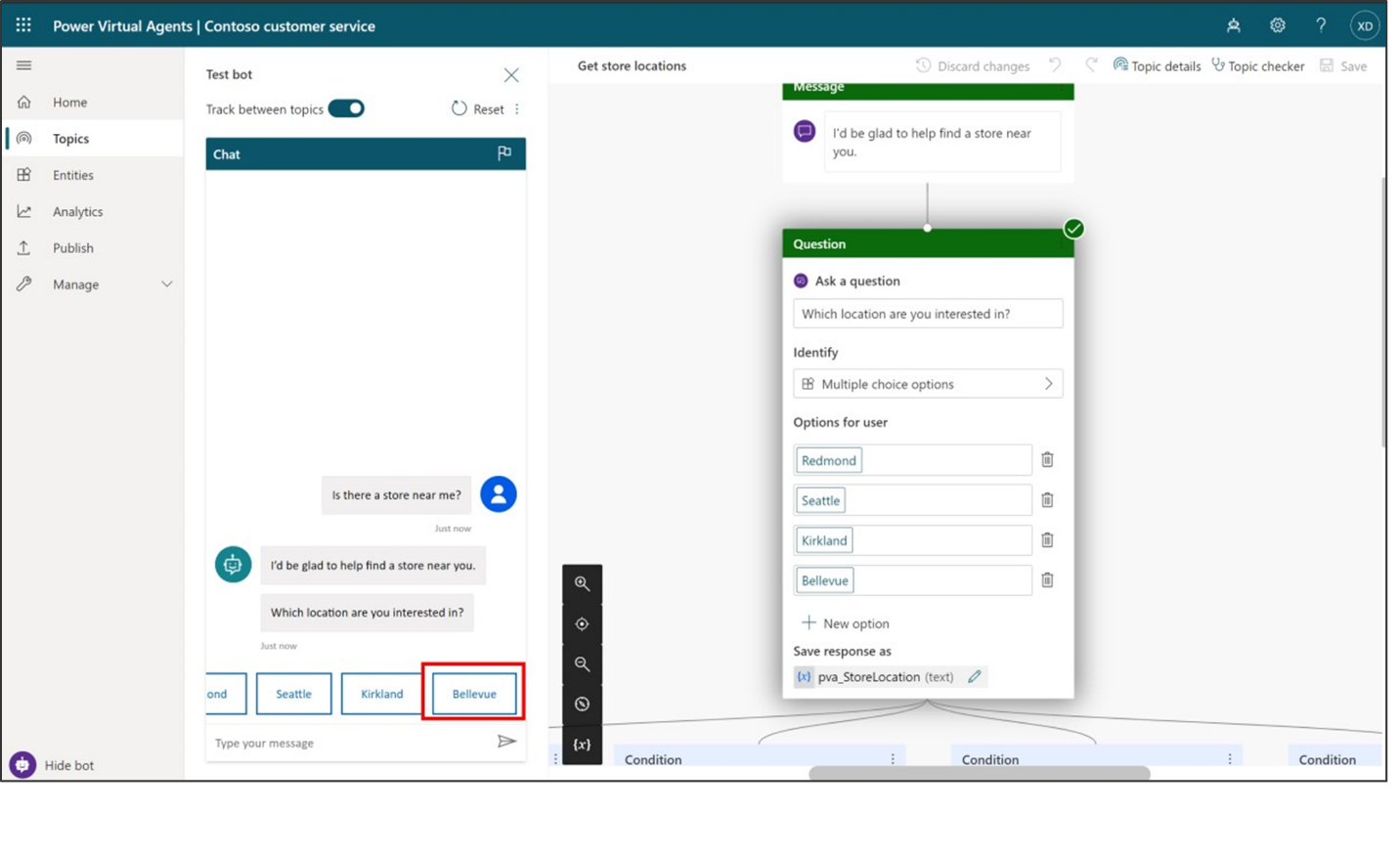](https://docs.microsoft.com/en-us/learn/modules/power-virtual-agents-bots/media/lab-26.png#lightbox)

The bot replies with location info for Bellevue store. Notice that the conversation continues in the **End of conversation** system topic. Feel free to keep chatting with the test bot.

## Task 4: Publish your bot to the demo site for testing

Power Virtual Agents provides a demo website so that you can invite anyone to test your bot by sending them the URL. This demo website is useful to gather feedback to improve the bot content before you activate the bot for your real customers.

1. Go to the **Publish** tab on the left navigation pane.
2. Select **Publish** to push the latest bot topics to the demo website. You will need to do this before you use the demo site the first time and also after you make changes to the bot topics that you want people to test on the demo website. (When you've created your real chatbot, you will Publish each time you want to make updated topics available to your customers.)

[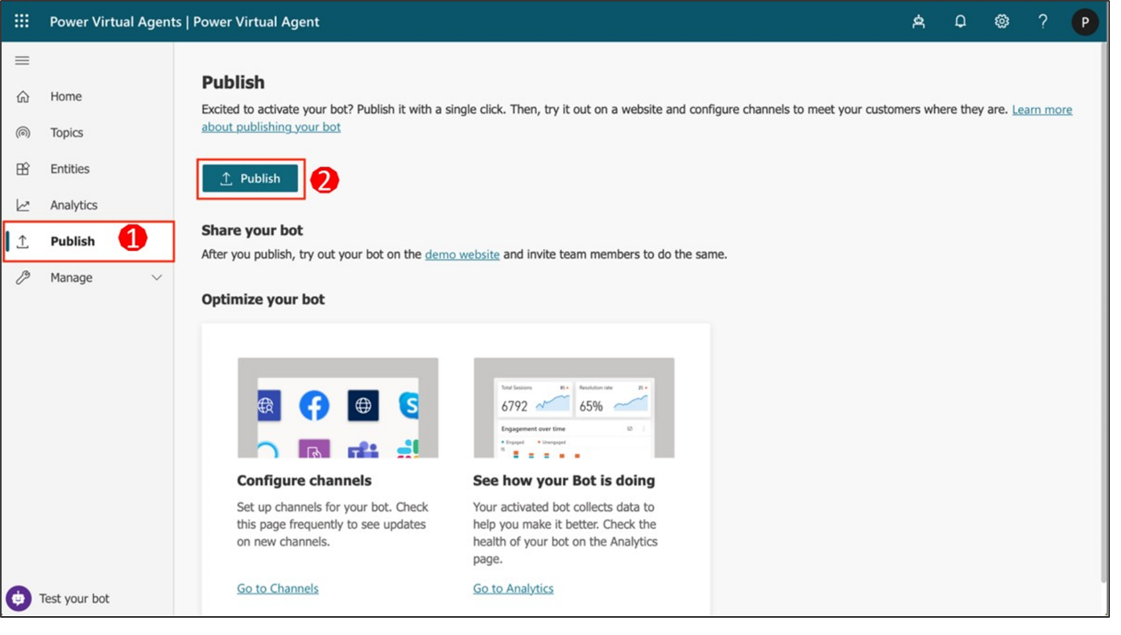](https://docs.microsoft.com/en-us/learn/modules/power-virtual-agents-bots/media/lab-27.png#lightbox)

The publishing process will check for errors in the bot topics whose Status is On. Publication should take only a few minutes.

You will see a message at the top of the screen when publishing is complete.

1. Select the link for the **demo website**.

[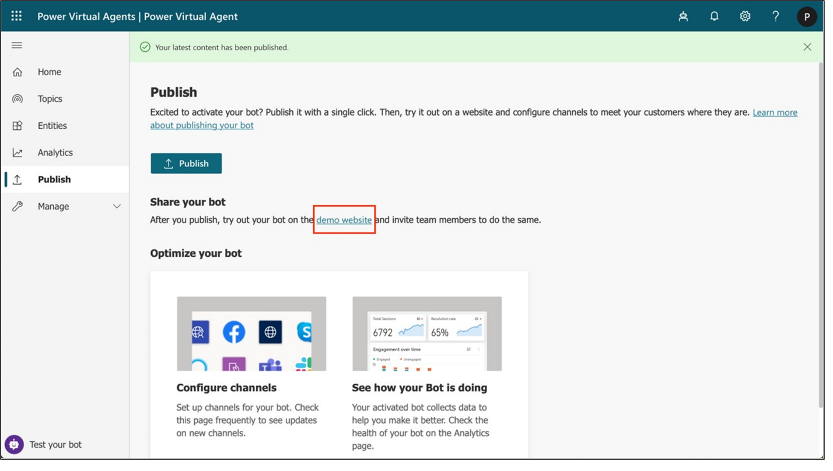](https://docs.microsoft.com/en-us/learn/modules/power-virtual-agents-bots/media/lab-28.png#lightbox)

1. When the demo site window opens, you can interact with the bot canvas by typing at the **Type your message** prompt or by selecting a starter phrase from the provided options.

[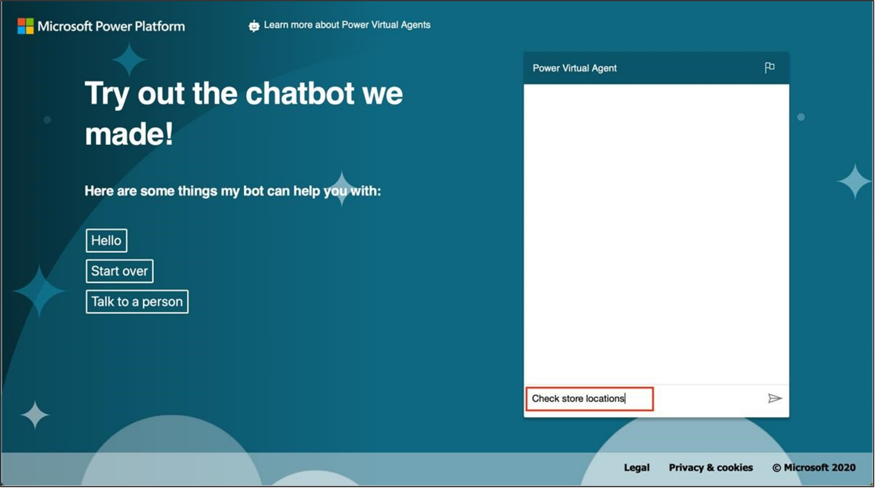](https://docs.microsoft.com/en-us/learn/modules/power-virtual-agents-bots/media/lab-29.png#lightbox)

1. You can share the URL of the **demo website** with your team.